ML HW5 Report

B09901066 謝承修

1. **Visualize the similarity between different pairs of positional embedding and briefly explain the result.**

As seen in the figure, the diagonal elements have the largest similarity as we expected, since the similarity between the embedding of close positions is much stronger.

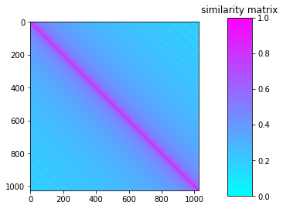

1. **Clip gradient norm and visualize the changes of gradient norm in different steps. Circle two places with gradient explosion.**

As seen in the following figure, there exists several gradient explosion like the marked ones.

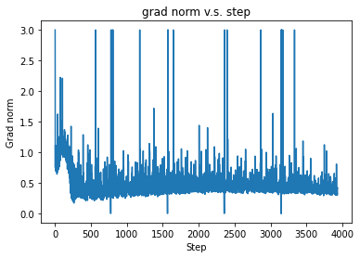



p.s. 我畫出的版本不是我交出去的版本，因為我忘記存grad norm了哭啊。